Summary of Simode Experiments

Harold Ship, May 1, 2019

# Introduction

In this simulation study we explored the performance profile of the separable least squares (SLS) method of estimating the parameters of initial value problems (IVPs), and compare it with non-linear least squares (NLS) regression. In order to do that, we used simode R package to solve a collection of initial value problems. We chose some models with only linear parameters, and others with both linear and non-linear parameters. We are interested in the following questions:

1. Does SLS perform well in determining the linear and non-linear parameters of IVPs?
2. Under what conditions does SLS perform better than NLS, and vice versa?

# Setup:

MacBook Pro 2014

RStudio

R 3.4

# Method

We ran sets of simulations, based on the following known models of IVPs:

* FitzHugh-Nagumo
* S-Systems
* SIR semi-linear
* Lotka-Volterra
* Lotka-Volterra with sinusoidal seasonal adjustment.

Our experiments generated random observations based on a gaussian error distribution, centered at the “true” parameter values. We then used both SLS and NLS to compute estimate the parameters using integral matching.

In most cases, we varied the “prior information”, meaning the initial guess for the parameter values. Higher quality “prior information” means that the initial guesses of the parameter values is closer to the truth. Then we compared the variances of the resulting parameter estimates. However, in cases where the models are not identifiable (such as the case in the S-system example) where different parameter estimates may lead to the same (or very similar) model fit to the data, we compared the integral matching loss.

# of Monte Carlo simulations

# of sample size n

# equations form or reference to it

# Results

## FitzHugh-Nagumo

We tried two experiments, varying the value of the V parameter. With V=-1, R=1, we saw that the variance of the parameter estimates using SLS was less than 0.5 times the NLS. When we changed V=-0.5, the variance of the parameter estimates was lower for most cases.

We solve the following differential equations, varying the initial value of R:

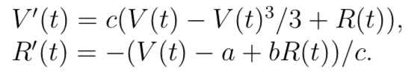

Sample size: 40

Number of MC simulations: 50





## S-Systems

We tried an S-System example, with 4 differential equations and 4 unknowns and 8 parameters. The equations were:

x1’ = alpha1*(x3^g13)-beta1*(x1^h11)

x2’ = alpha2*(x1^g21)-beta2*(x2^h22)

x3’ = alpha3*(x2^g32)-beta3*(x3^h33)*(x4^h34)

x4’ = alpha4*(x1^g41)-beta4*(x4^h44)

We compared the integral matching loss function using NLS and SLS, with the SLS error being significantly lower when the quality of the prior information was low.

Sample size: 50

Number of MC simulations: 50



## SIR model

We next tried a semi-linear SIR model over 5 years for 2 age groups. Our non-linear parameters were the initial values of S during the 5 years. We measured the integral matching errors of the simulations, and found that SLS and NLS performed the same. We then compared the variance of the parameter estimates, and it too was the same, as indicated by the ratio of 1.

Simplifying so that kappa and gamma are known, we solve for 5 years of beta for 2 groups:

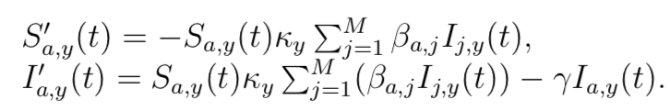

However, we will treat the problem as only partially specified; that is, the initial values of S are unknown, and so we will compute it.

Sample size: 18

Number of MC simulations: 50





## Lotka-Volterra

The Lotka-Volterra predator-prey model has only linear parameters. We show the variance ratio of SLS/NLS for the variance of the linear parameters. It is exactly 1, independent of prior information. We ran simulations using sigma=0.1 and sigma=0.4. This suggests that the performance of SLS and NLS may be the same when all of the parameters are linear.

We solve for the parameters of:

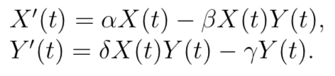

Sample size: 100

Number of MC simulations: 50

#histograms of parameter estimates





### Distribution of the estimates





## Lotka-Volterra with Seasonal Variation

Finally, we add seasonal variation to the Lotka-Volterra system in the form of sinusoidal non-linear parameters. Also, rather than varying the quality of the prior information, we varied the *sample size.* In this instance, we can see from the variance ratio graph that the *linear* parameters estimates have much lower variance using SLS, whereas the *nonlinear* parameters are much more similar for both techniques. This is further emphasized in the bar charts below.

We note that the parameter estimates are highly sensitive to the lower and upper bounds provide to simode.

We want to solve for the parameters of the following equations:

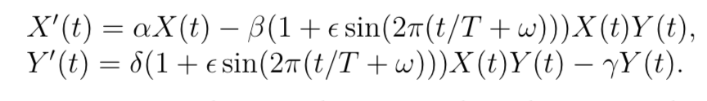

Sample size: 100, 400, 900, 1600

No of MC simulations: 100





We next examine the effect of sample size on the integral matching loss It appears that the sample size does not affect the integral matching error in any significant way.



### Distribution of the estimates

For the smallest sample size of 100, we see that the estimates for the linear parameters have unimodal distributions. The variance of the estimates does not appear to be too different.



However, for the non-linear parameters, there is a tendency to estimate them at or near zero.





For 1,600 observations, the linear parameter estimates are more uniformly distributed, while the non-linear estimate distributions look more like the ones for n=100.



# Discussion

From our preliminary tests, it appears that SLS performs as well or better than NLS for estimating the parameters of IVPs. This is true for both linear and non-linear parameters. For the Lotka-Volterra IVP, we observed that when estimating linear parameters, the two techniques were equivalent. However, when we added non-linear seasonal parameters we observed that SLS performed significantly better than NLS on the linear parameter estimates.